Newfield Community Council Fund

Guidelines for
Community Micro-Grant

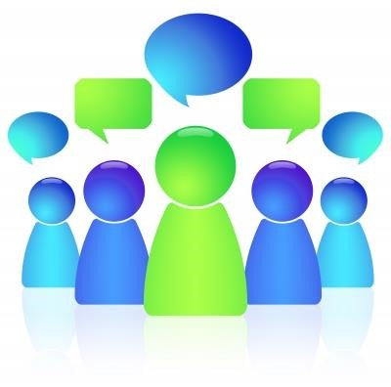

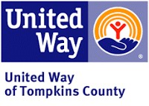

The Newfield Community council is made up of representatives of those organizations that have historically received support through the United Way of Tompkins County. The Council helps guide the grant request and management process and distributes funds received from the United Way.
Discretionary funds will be used to support micro grants within the Community of Newfield for the express purpose of benefiting the community through:

- activities
- Supplies and needed infrastructure
- Single events

Who may apply :

- Community members
- Community organizations

The following requests are not eligible for consideration:

- For profit activities
- Those activities without a clear time frame
- Those activities not benefiting Newfield community members
- Salaries
- Large Equipment purchases or rental
- General fundraising

PRIORITY WILL BE GIVEN TO NEW PROJECTS

Grant amounts will be available up to $ 300.

All requests will be considered as part of the review process.

This round of applications will be accepted from April 10, 2024, for a period of three weeks. Following the close of applications, Friday May 3, 2024 the Council will review all requests. Awards will be made immediately following the review period, approximately May 15, 2024. Applicants not receiving grants in a given cycle may reapply. Organizations and/or individuals having received a past award may re-apply.

A final report, included in your award packet, will be due following completion of your project. If project is not completed then a progress report will be required. Failure to send a report will affect future eligibility.

Please fill out the following application and return to The Newfield Public Library. For further information or questions call 607-379-1997 or email maria.lloydjones@gmail.com

Maria Lloyd-Jones, Chairman

APPLICANT INFORMATION
- Applicant name (and Title if applicable)
_________________________________________________________________________
- Organization
________________________________________________________________________
- Contact information:
- Address ______________________________________________________________________________
- Phone # ______________________________________________________________________________
- Email ______________________________________________________________________________
- Project Title
______________________________________________________________________________
- Contact person
______________________________________________________________________________
Brief description of your idea and purpose:
__________________________________________________________________________________________
__________________________________________________________________________________________
__________________________________________________________________________________________
__________________________________________________________________________________________
__________________________________________________________________________________________
__________________________________________________________________________________________ __________________________________________________________________________________________ __________________________________________________________________________________________
Timeframe
Provide detailed information on the expected timetable for the project. Break the project into phases, and provide a schedule for each phase.
 | Description of Work | Start and End Dates
Starting project
Project in motion
Ending project

Budget
Will these funds cover your entire project? Yes _____ No _____
If no, please describe where else you will be receiving funding.
_____________________________________________________________________________________
_____________________________________________________________________________________
_____________________________________________________________________________________
_____________________________________________________________________________________
_____________________________________________________________________________________
_____________________________________________________________________________________
State the proposed costs and budget of the project. Also include information on how you intend to manage the budget.
Project stages (for example: beginning, middle, ending) | Description of Project Expense (example: 5 shovels at $5 each) | Estimated Cost  (example: $25)
 | Total *
*use back of application if necessary
Additional comments regarding your plan, timing, and/or budget:
__________________________________________________________________________________________
__________________________________________________________________________________________
__________________________________________________________________________________________
__________________________________________________________________________________________
If you are successful in receiving the award, to whom should the check be made out to: __________________
All applications must be received by 5PM, Friday, May 3 at the Newfield Public Library

Name ___________________________________________ (Please Print
Signature ________________________________________ Date _________________________

Newfield Community Council Micro grant Final Report
Please return by December 1, 2024

Name of Organization _________________________________________________________________

Project description ____________________________________________________________________________________________________________________________________________________________________________________________________________________________________________________________________________________________________________________________________________________________________________________________________________________________________________________________________________________________________________________________________________________________________________________________________________________________________________________________________________________________________________________________ ____________________________________________________________________________________________________________________________________________________________________________________________________________________________________________________________________________________________________________________________________________________________________________________________________________________________________________________________________________________________________________________________________________________________________________________________________________________________________________________________________________________________________________________________
Project Outcome (How did it go? Any data would be appreciated, too)
____________________________________________________________________________________________________________________________________________________________________________________________________________________________________________________________________________________________________________________________________________________________________________________________________________________________________________________________________________________________________________________________________________________________________________________________________________________________________________________________________________________________________________________________________________________________________________________________________________________________________________________________________________________________________________________________________
Funds used (amount) and what used for
_________________________________________________________________________________________________
_________________________________________________________________________________________________
_________________________________________________________________________________________________
Additional comments _______________________________________________________________________________ _________________________________________________________________________________________________

Person submitting report (please print) __________________________________________________________________

Signature __________________________________________________ Date __________________________________

Please return to the Newfield Public Library or by email to: maria.lloydjones@gmail.com

